**Assignment 1**

**Exercise 1**

Each salesperson at Puchett, Sheets, and Hogan Insurance Agency is rated either below average, average, or above average with respect to sales ability. Each salesperson is also rated with respect to his or her potential for advancement either fair, good, or excellent. These traits for the 500 salespeople were cross-classified into the following table.

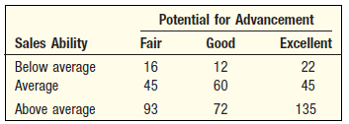

**a.** What is this table called?

**b.** What is the probability a salesperson selected at random will have above average sales ability and excellent potential for advancement?

**c.** Construct a tree diagram showing all the probabilities, conditional probabilities, and joint probabilities.

**Exercise 2**

Suppose the two events *A* and *B* are mutually exclusive. What is the probability of their joint occurrence?

**Exercise 3**

In recent years, due to low interest rates, many homeowners refinanced their home mortgages. Linda Lahey is a mortgage officer at Down River Federal Savings and Loan. Below is the amount refinanced for 20 loans she processed last week. The data are reported in thousands of dollars and arranged from smallest to largest.

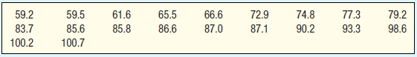

**a.** Find the median, first quartile, and third quartile.

**b.** Find the 26th and 83rd percentiles.

**c.** Draw a box plot of the data.

**Exercise 4**

The Apollo space program lasted from 1967 until 1972 and included 13 missions. The missions lasted from as little as 7 hours to as long as 301 hours. The duration of each flight is listed below.



**a.** Explain why the flight times are a population.

**b.** Find the mean and median of the flight times.

**c.** Find the range and the standard deviation of the flight times.